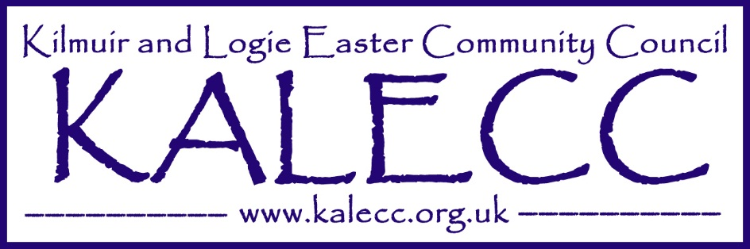

**DRAFT Minutes of meeting on the 21.11.2024 at 19.30 at Mercat Centre**

Meeting commenced at 19.35

**1.Present** Tom Anderson **TA**, Allan Mcleod **AM,** HCllr Maureen Ross **MR,** Sandra MacDonald **SM**, Ryan Barrowman **RB,** Ron Ferguson **RF**

**TA** welcomed and thanked everyone for attending the meeting.

**2. Apologies** Rita Fenton, HCllr Derek Louden and Cllr Laura Dundas

**3. Police Report** No Reports received. AM tabled a response from Police Scotland apologising for recognised lack of reports and also advising that no reports had been made of anti-social behaviour at Old Station Road. It was agreed to query this as it has been advised that the police have been attended the area several times. The recent fire at the ‘love tree’ was also discussed and to be raised with Police Scotland. **MR** advised that the proposed Joint Community Council could be a good way to communicate with services generally.

**4.** **Minutes of meeting on 17.10.2024** Minutes approved by 1st **SM**, 2nd **RF**

**5. Matters arising from minutes**. **AM** highlighted an issues that was raised in the previous minutes regarding complaints from Milton residents of antisocial behaviour. This involves messy gardens that are attracting vermin & also unsafe use of fires that has resulted in Fire Scotland attending on several occasions. Post meeting note: Response was received from Housing. **AM** also highlighted an issue raised by **DM** at the previous meeting that a lack of drop kerbs to the old station road/ Urquhart close areas makes it impossible to use a mobility scooter. Roads Iain Moncrief to be contacted.

**6. Reports by Highland Councillors. MR** advised that the main forthcoming issue is that of the Scottish Gov. Budget. The capital roads budget for this year is spent and works being carried out now are from the revenue budget. The Highland Council Education has come under criticism and **MR** defended their performance when considering disruption of learning especially older children experienced during lockdowns. An update on the Tain 3 - 18 Campus and that a recent stakeholder meeting confirmed that the project is running late.

**7. Financial accounts** RB provided a report with current balance of £697.92 **RB** advised that Polnicol Hall are to issue 2 No. invoices which will need to be paid.

**8. Community Council issues**. **AM** advised that work had started on Safer routes to school projects that consist of a new path at School Road and new steps to rear of the Primary School. **RB** proposed to start using electronic banking, all agreed. **AM** agreed **8. Community Council issues**. (Continued) to become a signatory for the bank account. Discussion was held on the Xmas decorations. **AM** confirmed that Balnagown had generously agreed to supply a tree on 13th December. **AM** and **SM** to further discuss putting the Xmas lights up around Milton Village. Thanks to **TA** for organising laying of the Remembrance wreaths and to **RF** for taking part in the ceremony.

**9. Planning and Licensing**. None

**10. Correspondence**. **RB** agreed to attend Joint Community Council meeting on 11th December. Port of Cromarty firth meeting on 12th December attendance to be confirmed. Response to Ardross Community Council to be reviewed. It was agreed to write a letter of support for the relocation of Invergordon Museum. Post meeting note **AM** issued 22nd Nov.

**12. Any Other Business**;

**13. Date of next meeting.** 16th January 2025 7:30pm at Polnicol Hall.

**14. Beinn Tharsuinn.** None.

**TA** thanked everyone for their attendance and time.

Meeting concluded 20.35

*Allan Mcleod Secretary, Kilmuir and Logie Easter Community Council*